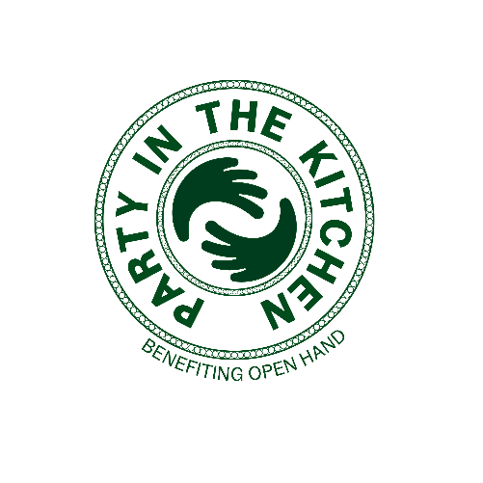

**FOR MORE INFORMATION:**

Caroline Day

BRAVE Public Relations

404.233.3993

[cday@emailbrave.com](mailto:cday@emailbrave.com)

**Open Hand Celebrates Annual “Party in the Kitchen” Fundraiser**   
**at The Foundry at Puritan Mill, Sept. 26**

*Annual fundraiser brings Atlanta’s top chefs together for a night of culinary masterpieces, live music and exclusive auctions in support of Open Hand*

**ATLANTA (Aug 1, 2024)** – Open Hand invites guests to the 21st annual **Party in the Kitchen** fundraiser at 6:30 PM on **Thursday, Sept. 26** at **The Foundry at Puritan Mill.** As Atlanta’s premier culinary social occasion, Party in the Kitchen is set to showcase 20 of Atlanta’s finest chefs in a celebration of culinary excellence and community spirit. Attendees can expect to enjoy an evening of creative cuisine, innovative mixology, entertainment, auctions and more. Live music from The American Flyers will enhance the patron experience during this unforgettable evening in support of Open Hand’s mission. Chefs Peter Kaiser and Kevin Rathbun return as the chef co-chairs of the evening, while Anne Barge Clegg and Roger Smith join as new event co-chairs for this year.   
  
“We are honored to have Anne Barge Clegg and Roger Smith join our chef co-chairs Chef Peter Kaiser and Chef Kevin Rathbun for this year's Party in the Kitchen,” said Open Hand CEO Matthew Pieper. “Not only are they raising critical funds for our mission, they are also ushering in a new era of Open Hand as we relocate our campus to the Westside of Atlanta.”

Local chefs including Kevin Rathbun, Ian Winslade, Peter Kaiser, Chris Hall and Arnaldo Castillo will come together to tempt tastebuds with an array of Atlanta’s most exquisite cuisine. In addition to savoring local bites and cocktails, attendees will also have the opportunity to participate in live and silent auctions, with an exclusive selection of luxury items including vacation homes, sporting events, dining experiences and more.

Prior to the main event, Open Hand will host a **Patron Reception** for VIP guests in the organization’s **new state-of-the-art Community Nutrition Campus** at 6:30 PM on Thursday, Sept. 12. Patron tickets are $1,000 and include access to the main event. VIP patrons and sponsors will get an exclusive first look of the campus over cocktails and light bites, as well as the chance to bid on a surprise live auction item only available to those in attendance.

Proceeds raised from Party in the Kitchen support Open Hand’s programs, providing healthy home-delivered meals and nutrition education to those impacted by chronic disease, as well as homebound seniors and at-risk youth and families. Tickets to the Party in the Kitchen’s main event are available now for $350. For more information or to purchase tickets, visit [openhandatlanta.org/pitk](https://openhandatlanta.org/pitk/).

###

**About Open Hand**

Open Hand is one of the largest community-based providers of home-delivered meals and nutrition services in the U.S. Founded in 1988, the nonprofit delivers delicious, nourishing meals and nutrition education to thousands of seniors, children and families, and our neighbors who are at risk for or have a disability or illness. Open Hand is one of the largest community-based providers of home-delivered meals and nutrition services in the U.S. Founded in 1988, the nonprofit delivers delicious, nourishing meals and nutrition education to thousands of seniors, children and families, and our neighbors who are at risk for or have a disability or illness. In 2023, Open Hand cooked and delivered its 35 millionth high-quality, health-promoting meal to a neighbor in need. With custom menus to address specific health conditions, all Open Hand meals are approved by a registered dietitian nutritionist and meet or exceed the most rigorous nutritional standards set by the American Diabetes Association, the USDA, and the American Heart Association.

To learn more about Open Hand’s programs, call 404-872-8089 or visit [openhandatlanta.org](http://www.openhandatlanta.org). Open Hand is located at 1380 West Marietta St. NW, Atlanta, GA 30318.